SMART WASTE MANAGEMENT USING ARDUINO AND GSM

ACKNOWLEDGEMENT

We express our sense of gratitude to our respected project guide **Mrs. Swati Tawade** for her valuable help and guidance. Her involvement right from conceptualization of the study through its execution and meticulous perusal of the manuscript ensured its timely completion.

We are thankful to **Dr. D . K . Nayak ,** principal of **VPM’s Polytechnic, Thane** for permitting us to utilize all the necessary facilities of the institution.

We are thankful to **Mrs. Suhasini Shukla**  Head of Department of Computer Engineering for her perfect guidance by giving timely suggestion throughout the tenure of our project and also for her continuous supervision an valuable guidance for improvements and completion of our project successfully.

We are also thankful to the entire staff of CO department for their kind co-ordination and respective guidance.

**ABSTRACT**

The overflowing of garbage bins is one of the major problems faced in societies and hospitals . As the garbage is split out from dust bins it results in to unhygienic condition, illness and bad smell for all people near that area. Hence, we are designing the system based on Arduino for monitoring garbage bins. The dustbins are interfaced with microcontroller-based system having ultrasonic sensor and gas sensor. Ultrasonic sensor shows the level of garbage in dustbin and gas sensor detects the presence of different combustible gases around the dustbin. When garbage reaches the level of sensor or if combustible gas is detected then SMS alert will be send to the user on mobile phone through GSM.It will also help to handle waste in the future upcoming Smart cities. Hence intelligent garbage monitoring system will make the garbage collection more efficient.

Keywords: GSM, LPG, LCD, IC, Arduino, micontroller, combustible,Smart cities.

Contents

CHAPTER NO.1 5

**INTRODUCTION** 5

CHAPTER NO. 2 6

**FEASIBILITY** 6

CHAPTER NO. 3 7

**REQUIREMENTS** 7

HARDWARE REQUIREMENTS 7

SOFTWARE REQUIREMENTS 7

CHAPTER NO. 4 8

**ALGORITHMS AND CHARTS** 8

4.4 Algorithm 11

CHAPTER NO. 5 12

**IMPLEMENTATION** 12

**5.2 SCREENSHOTS** 31

5.3 CODING 33

CHAPTER NO. 6 39

**TESTING** 39

CHAPTER NO.7 45

7.1 FEATURES 45

7.2 ADVANTAGES 45

CHAPTER NO. 8 46

**FUTURE SCOPE** 46

**CONCLUSION** 46

CHAPTER NO. 10 47

# CHAPTER NO.1

## **INTRODUCTION**

**Existing System:**

In existing system the dustbin is deployed with ultrasonic sensor.The ultrasonic sensor is used to measures the level of garbage bin.When the dustbin is full the ultrasonic sensor sends signals to the microcontroller.The microcontroller then processes the signals and notifies it to the intended user by turning the LED on and giving a buzzer. Hence the LED-on state indicates that the dustbin is full.

**Proposed System:**

In present day, many times we see that garbage bins or dustbins placed at residential societies or in hospitals are not managed properly. It creates unhygienic conditions for all members of society and creates bad smell around the surroundings which leads in spreading of diseases and human illness.Hence to avoid such situation we are designing “**Smart Waste Management Using Arduino &GSM**”. In this proposed system, we have designed system to manage the waste in buildings more efficiently. Hereafter, it is not possible in high raised buildings to collect waste from every floor so the method of garbage chute is implemented. A garbage chute system is a long vertical space passing by each floor in a building. It includes a door on each floor where residents can dispose of their garbage into the chute. Garbage placed in the chute drops to a compactor or dumpster at the bottom[1]. The dustbin is deployed with Ultrasonic and Gas sensors. These sensors detect the level of garbage as well as leakage of gas. The LCD screen is used to display the status of garbage. After garbage bin is about to be full the system will send an alert SMS as ‘Bin is Full’ to the registered number (such as the person who is in charge of garbage collection in society). Also it will send SMS as ‘Gas leak detected’ whenever toxic gases are detected.

Hence intelligent garbage monitoring system will make the garbage collection more efficient.

# CHAPTER NO. 2

## **FEASIBILITY**

**2.1** ECONOMICAL FEASIBILITY

For any system if the expected benefits equal or exceed the expected costs, the system can be judged to be economically feasible. In economic feasibility, cost benefit analysis is done in which expected costs and benefits are evaluated. Economic analysis is used for evaluating the effectiveness of the proposed system.

In economic feasibility, the most important is cost-benefits analysis. As the name suggests, it is an analysis of the costs to be incurred in the system and benefits derivable out of the system.

**2.2** TECHNICAL FEASIBILITY

**Hardware:**

Assessing technical feasibility includes evaluating the ability of computer hardware and software to handle workloads adequately. Hardware determinations can come only in conjunction with determining human information requirements. Knowledge of the organizational structure.

**Software:**

Analysts and organizations are increasingly faced with a make, buy, or outsource decision when assessing software for information systems projects, particularly when contemplating upgrades to existing or legacy systems. As an analyst, part of the expertise you are developing is to make sound judgments regarding developing software versus the purchase of COTS software for new and existing systems.

# CHAPTER NO. 3

## **REQUIREMENTS**

HARDWARE REQUIREMENTS**: -**

* Power Supply (+5V DC Adapter)
* Ultrasonic Sensor (HC-SR04)
* Gas Sensor (MQ 6)
* Arduino (Nano)
* GSM ( SIM 32 )
* LCD display (JHD 162A)
* Buzzer (Piezo Electric buzzer +5V)

SOFTWARE REQUIREMENTS**: -**

* Software ( Arduino IDE)
* Language (C/C++ programing)

# CHAPTER NO. 4

## **ALGORITHMS AND CHARTS**

**4.1** BLOCK DIAGRAM**: -**

**POWER SUPPLY**

**GSM**

**ARDUINO BOARD**

**ULTRASONIC SENSOR**

**USER MOBILE**

**LCD SCREEN**

**GAS SENSOR**

**BUZZER**

**4.1 Block Diagram**

**4.2** FLOWCHART**:**

**Start**

**Gas Sensor**

**Ultrasonic Sensor**

**If level 0%-25%**

**If gas is detected**

**N Y N**

**Y**

**If level 25%-50%**

**N Y**

**Display Status on LCD Screen**

**If level 50%-75%**

**N Y**

**Send SMS to User Mobile**

**Stop**

**4.2 Flowchart**

**4.3** USE CASE DIAGRAM

# 

**USER 1**

**SYSTEM**

**USER 2**

**4.3 Use Case Diagram**

# 4.4 Algorithm

1. Start
2. Set up ports
3. Start taking data of sensor
4. continuously monitor level of garbage and presence of combustible gases
5. If garbage level between 0-25% then display message as “Garbage is low”.
6. If garbage level between 25-50% then display message as “Garbage is medium”.
7. If garbage level between 50-75% then display message as “Garbage is high” and send message to the registered user.
8. If Combustible gases(such as LPG, Methyl) is detected then “Gas leaked” message is detected and SMS alert is send to the registered mobile through GSM.
9. Buzzer sound is given when garbage is full or gas is leaked in the dustbin.
10. Stop

# CHAPTER NO. 5

## **IMPLEMENTATION**

**5.1** DESCRIPTION**:**

**5.1.1**POWER SUPPLY

This circuit is a small +5V power supply, which is useful when experimenting with digital electronics. Small inexpensive wall transformers with variable output voltage are available from any electronics shop and supermarket. Those transformers are easily available, but usually their voltage regulation is very poor, which makes them not very usable for digital circuit experimenter unless a better regulation can be achieved in some way. The following circuit is the answer to the problem.

This circuit can give +5V output at about 150 mA current, but it can be increased to 1 A when good cooling is added to 7805 regulator chip. The circuit has over overload and terminal protection.

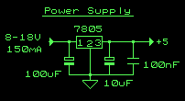

Fig 5.1.1:Power circuit diagram

**FEATURES**

* Gives out well regulated +5V output, output current capability of 100 mA
* Built-in overheating protection shuts down output when regulator IC gets too hot
* Very simple and easy to build
* Very stable +5V output voltage, reliable operation
* Easy to get, uses only very common basic components
* Based on datasheet example circuit, I have used this circuit succesfully as part of many electronics projects
* Part of electronics devices, small laboratory power supply
* Unregulated DC 8-18V power supply
* Needed output current + 5 mA
* Few for the electronics components + the input transformer cost

**5.1.2 REGULATED IC (7805)**

**picture of 7085 regulator**

**Fig 5.1.2: Pin diagram of IC**

The LM78XX/LM78XXA series of three-terminal positive regulators are available in the TO-220/D-PAK package and with several fixed output voltages, making them useful in a Wide range of applications. Each type employs internal current limiting, thermal shutdown and safe operating area protection, making it essentially indestructible. If adequate heat sinking is provided, they can deliver over 1A output Current. Although designed primarily as fixed voltage regulators, these devices can be used with external components to obtain adjustable voltages and currents.

* + Unregulated voltage in
  + Ground
  + Regulated voltage out

**FEATURES**

• Output Current up to 1A.

• Output Voltages of 5, 6, 8, 9, 10, 12, 15, 18, 24V.

• Thermal Overload Protection.

• Short Circuit Protection.

• Output Transistor Safe Operating Area Protection.

**5.1.3** **TRANSFORMER**

Transformers convert AC electricity from one voltage to another with a little loss of power. Step-up transformers increase voltage, step-down transformers reduce voltage. Most power supplies use a step-down transformer to reduce the dangerously high voltage to a safer low voltage.

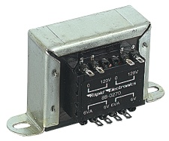

**Fig 5.1.3: Transformer**

The input coil is called the primary and the output coil is called the secondary. There is no electrical connection between the two coils; instead they are linked by an alternating magnetic field created in the soft-iron core of the transformer. The two lines in the middle of the circuit symbol represent the core. Transformers waste very little power so the power out is (almost) equal to the power in. Note that as voltage is stepped down and current is stepped up.

The ratio of the number of turns on each coil, called the turn’s ratio, determines the ratio of the voltages. A step-down transformer has a large number of turns on its primary (input) coil which is connected to the high voltage mains supply, and a small number of turns on its secondary (output) coil to give a low output voltage.

TURNS RATIO = (Vp / Vs) = ( Np / Ns )

Where,

Vp = primary (input) voltage.

Vs = secondary (output) voltage

Np = number of turns on primary coil

Ns = number of turns on secondary coil

**5.1.4 RESISTOR**

A resistor is a two-terminal electronic component designed to oppose an electric current by producing a voltage drop between its terminals in proportion to the current, that is, in accordance with Ohm's law:

V = IR

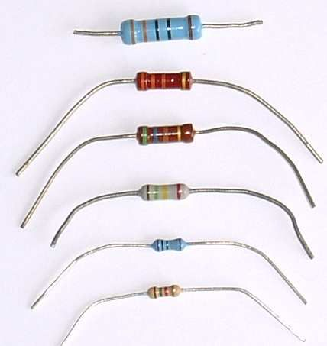

**Fig 5.1.4: Resistors**

Resistors are used as part of electrical networks and electronic circuits. They are extremely commonplace in most electronic equipment. Practical resistors can be made of various compounds and films, as well as resistance wire (wire made of a high-resistivity alloy, such as nickel/chrome).

**5.1.5 CAPACITORS**

A capacitor or condenser is a passive electronic component consisting of a pair of conductors separated by a dielectric. When a voltage potential difference exists between the conductors, an electric field is present in the dielectric. This field stores energy and produces a mechanical force between the plates. The effect is greatest between wide, flat, parallel, narrowly separated conductors.

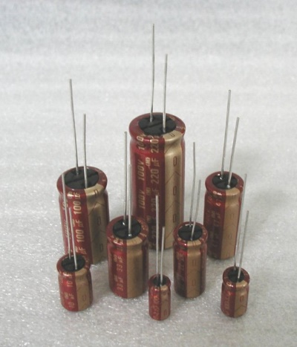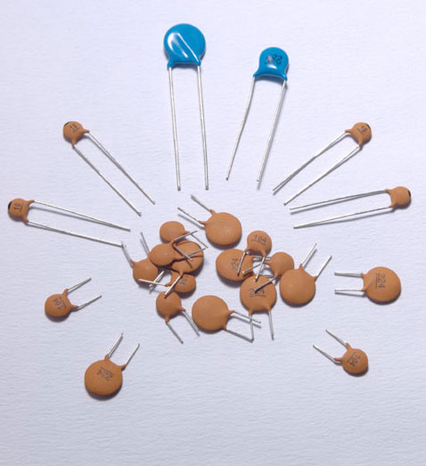

**Fig 5.1.5 Electrolytic and Ceramic capacitors**

An ideal capacitor is characterized by a single constant value, capacitance, which is measured in farads. This is the ratio of the electric charge on each conductor to the potential difference between them. In practice, the dielectric between the plates passes a small amount of leakage current. The conductors and leads introduce an equivalent series resistance and the dielectric has an electric field strength limit resulting in a breakdown voltage.

The properties of capacitors in a circuit may determine the resonant frequency and quality factor of a resonant circuit, power dissipation and operating frequency in a digital logic circuit, energy capacity in a high-power system, and many other important aspects.

**5.1.6 RECTIFIER**

A rectifier is an electrical device that converts [alternating current](http://en.wikipedia.org/wiki/Alternating_current) (AC), which periodically reverses direction, to[direct current](http://en.wikipedia.org/wiki/Direct_current) (DC), current that flows in only one direction, a process known as rectification. Rectifiers have many uses including as components of[power supplies](http://en.wikipedia.org/wiki/Power_supply) and as [detectors](http://en.wikipedia.org/wiki/Detector_(radio)) of [radio](http://en.wikipedia.org/wiki/Radio) signals. Rectifiers may be made of [solid state](http://en.wikipedia.org/wiki/Solid_state_(electronics))[diodes](http://en.wikipedia.org/wiki/Diode), [vacuum tube](http://en.wikipedia.org/wiki/Vacuum_tube) diodes, [mercury arc valves](http://en.wikipedia.org/wiki/Mercury_arc_valve), and other components. The output from the transformer is fed to the rectifier. It converts A.C. into pulsating D.C. The rectifier may be a half wave or a full wave rectifier. In this project, a bridge rectifier is used because of its merits like good stability and full wave rectification. In positive half cycleonly two diodes (1 set of parallel diodes) will conduct, in negative half cycle remaining two diodes will conduct and they will conduct only in forward bias only.

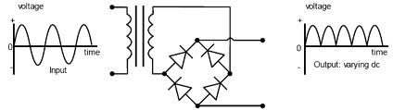

**Fig 5.1.6:Circuit of Rectifier**

**5.1.7 FILTER**

Capacitive filter is used in this project. It removes the ripples from the output of rectifier and smoothens the D.C. Output received from this filter is constant until the mains voltage and load is maintained constant. However, if either of the two is varied, D.C. voltage received at this point changes. Therefore, a regulator is applied at the output stage.

The simple capacitor filter is the most basic type of power supply filter. The use of this filter is very limited. It is sometimes used on extremely high-voltage, low-current power supplies for cathode-ray and similar electron tubes that require very little load current from the supply. This filter is also used in circuits where the power-supply ripple frequency is not critical and can be relatively high. Below figure can show how the capacitor charges and discharges.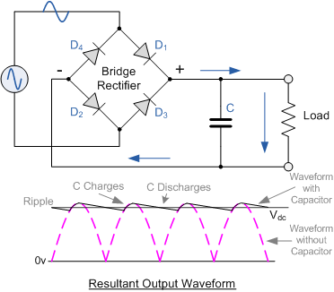

**Fig 5.1.7: Waveform of Fiter**

**5.1.8 DIODE**

Diodes are used to convert AC into DC these are used as half wave rectifier or full wave rectifier. Three points must he kept in mind while using any type of diode.

1. Maximum forward current capacity
2. 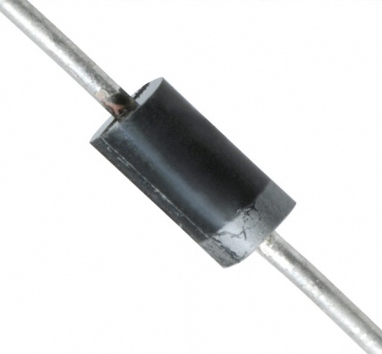Maximum reverse voltage capacity
3. Maximum forward voltage capacity

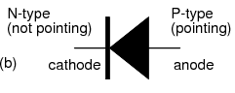

**Fig 5.1.8(a): Internal of Diode Fig 5.1.8(b): Diode**

Current Flow in the N-Type Material

Conduction in the N-type semiconductor, or crystal, is similar to conduction in a copper wire. Thatis, with voltage applied across the material, electrons will move through the crystal just as current wouldflow in a copper wire. This is shown in figure 1-15. The positive potential of the battery will attract thefree electrons in the crystal. These electrons will leave the crystal and flow into the positive terminal ofthe battery. As an electron leaves the crystal, an electron from the negative terminal of the battery willenter the crystal, thus completing the current path. Therefore, the majority current carriers in the N-typematerial (electrons) are repelled by the negative side of the battery and move through the crystal towardthe positive side of the battery.

Current Flow in the P-Type Material

Current flow through the P-type material is illustrated. Conduction in the P material isby positive holes, instead of negative electrons. A hole moves from the positive terminal of the P materialto the negative terminal. Electrons from the external circuit enter the negative terminal of the material andfill holes in the vicinity of this terminal. At the positive terminal, electrons are removed from the covalentbonds, thus creating new holes. This process continues as the steady stream of holes (hole current) movestoward the negative terminal.

**5.2.1**ULTRASONIC SENSOR

A special sonic transducer is used for the ultrasonic proximity sensors, which allows for alternate transmission and reception of sound waves. The sonic waves emitted by the transducer are reflected by an object and received back in the transducer. After having emitted the sound waves, the ultrasonic sensor will switch to receive mode. The time elapsed between emitting and receiving is proportional to the distance of the object from the sensor.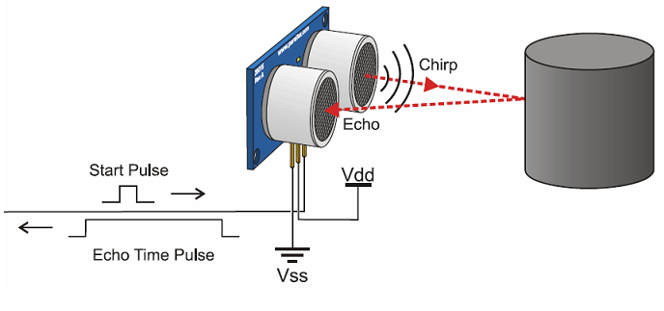

**Fig 5.2.1: Ultrasonic sensor**

Ultrasonic sensors generate high-frequency sound waves and evaluate the echo which is received back by the sensor, measuring the time interval between sending the signal and receiving the echo to determine the distance to an object.



**Fig 5.2.2Transmit and Receiver of sensor**

**SPECIFICATIONS**

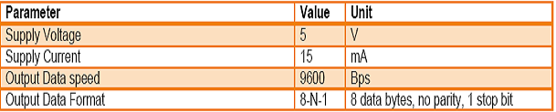

**5.3.1**COMBUSTIBLE GAS SENSOR ( MQ6)

MQ6 are a type of thick film metal oxide semiconductor, which offers low cost, long life and good sensitivity to target gasses while utilizing a simple electrical circuit. These sensors are especially suited to application in gas leak detectors for toxic and explosive gasses.

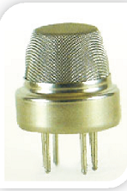

Fig 5.3.1: Gas sensor(MQ6)

**SENSIBLE GASES**

* Carbon monoxide
* Carbon
* L P G gas
* Methane
* Methyl alcohol
* Gasoline/Diesel fuel
* Natural gas
* Nitro benzene
* Chloroform
* Methyl
* Ethanol

**FEATURES**

* 5V operation
* Simple to use
* LEDs for output and power
* Output sensitivity adjustable
* Analog output 0V to 5V
* Digital output 0V or 5V

**SPECIFICATION**

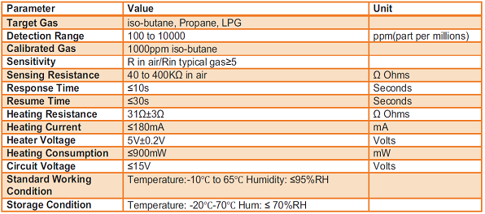

**5.4.1**ARDUINO NANO

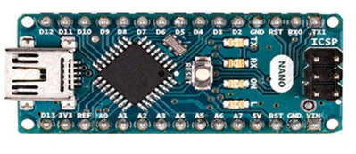

**Fig 5.4.1: Arduino Nano**

The Arduino Nano is a compact board similar to the UNO.The Arduino Nano is a small, complete, and breadboard-friendly board based on the ATmega328P (Arduino Nano 3.x). It has more or less the same functionality of the Arduino Duemilanove, but in a different package. It lacks only a DC power jack, and works with a Mini-B USB cable instead of a standard one.[2]

• Power

The Arduino Nano can be powered via the Mini-B USB connection, 6-20V unregulated external power supply (pin 30), or 5V regulated external power supply (pin 27). The power source is automatically selected to the highest voltage source.

• Memory

The ATmega328P has 32 KB, (also with 2 KB used for the bootloader. The ATmega328P has 2 KB of SRAM and 1 KB of EEPROM.

**TECHNICAL SPECIFICATION**

|  |  |
| --- | --- |
| Microcontroller | ATmega328 |
| Architecture | AVR |
| Operating Voltage | 5 V |
| Flash Memory | 32 KB of which 2 KB used by bootloader |
| SRAM | 2 KB |
| Clock Speed | 16 MHz |
| Analog IN Pins | 8 |
| EEPROM | 1 KB |
| DC Current per I/O Pins | 40 mA (I/O Pins) |
| Input Voltage | 7-12 V |
| Digital I/O Pins | 22 (6 of which are PWM) |
| PWM Output | 6 |
| Power Consumption | 19 mA |
| PCB Size | 18 x 45 mm |
| Weight | 7 g |
| Product Code | A000005 |

**5.5.1**GSM – AN OVERVIEW

GSM, Global System for Mobile communications, is today the most successful digital mobile telecommunication system. This second-generation (2G) system provides voice and limited data services and uses digital modulation with improved audio quality.

The different versions of GSM are:

1. GSM 900 band (850-915MHz up-link frequency and 935-960MHz downlink frequency)
2. GSM 1800 band or digital cellular system (DCS) 1800 band (1710-1785MHz up-link frequency and 1805-1880MHz downlink frequency)
3. Personal Communication service (PCS) 1900 band (1850-1910MHz up-link frequency and 1930-1990MHz downlink frequency)

GSM Mobile communication system can be intelligently used by electronic devices that can collect some data and send it to the central place using SMS or GSM data call. It’s required In-Vehicle Tracking Systems because GPS (Global Positioning System) can normally only receive location information from the satellites but cannot communicate back with them. Hence we need some other communication system like GSM to send this location information to the central control room. Other technologies can also be used but they are costlier.

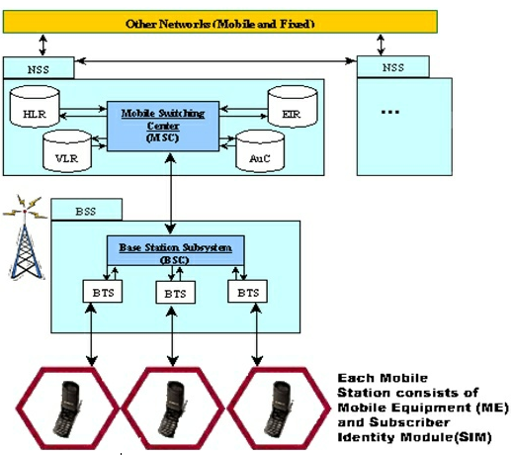

**Fig 5.5.1: Overview of GSM**

SMS is one of the unique features of GSM compared to older analog systems. For point-to-point SMS, a message can be sent to another subscriber to the service, and an acknowledgment of receipt is sent to the sender. SMS also can be used in Cell Broadcast mode to send messages such as traffic or news updates. Messages can be stored on the SIM card for later retrieval. SMS is effective because it can transmit short messages within 3 to 5s via the GSM network and doesn’t occupy a telephony channel. Moreover, the cost savings makes it a worthwhile choice.

**5.6.1** LCD DISPLAY

LCD (Liquid Crystal Display) screen is an electronic display module having a wide range of applications. A 16x2 LCD display is very basic module and is very commonly used in various devices and circuits. These modules are preferred over seven segments and other multi segment LEDs. The reasons being: LCDs are economical; easily programmable; have no limitation of displaying special & even custom characters (unlike in seven segments), animations and so on.

A 16x2 LCD means it can display 16 characters per line and there are 2 such lines. In this LCD each character is displayed in 5x7 pixel matrix. This LCD has two registers, namely, Command and Data.

The command register stores the command instructions given to the LCD. A command is an instruction given to LCD to do a predefined task like initializing it, clearing its screen, setting the cursor position, controlling display etc. The data register stores the data to be displayed on the LCD. The data is the ASCII value of the character to be displayed on the LCD. Click to learn more about internal structure of a LCD.

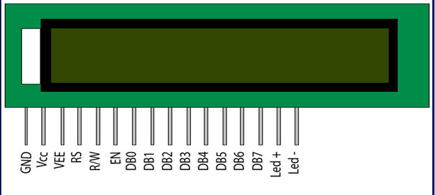

**Fig 5.6.1: LCD display**

**PIN DESCRIPTION**

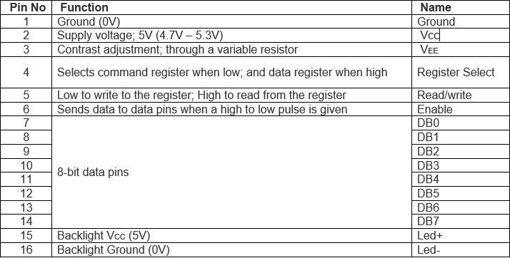

**5.7.1**BUZZER

A buzzer or beeper is an audio signaling device which may be mechanical, electromechanical, or piezoelectric . Typical uses of buzzers and beepers include alarm devices, timers and confirmation of user input such as a mouse click or keystroke.

Piezo buzzer is based on the inverse principle of piezo electricity discovered in 1880 by Jacques and Pierre Curie. The vibrating disk in a magnetic buzzer is attracted to the pole by the magnetic field. When an oscillating signal is moved through the coil, it produces a fluctuating magnetic field which vibrates the disk at a frequency equal to that of the drive signal

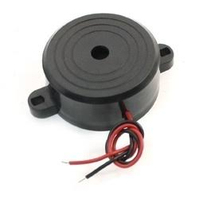

**Fig 5.7.1: Buzzer**

## **5.2** SCREENSHOTS

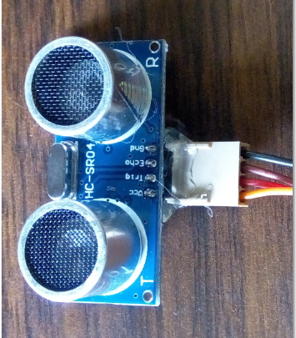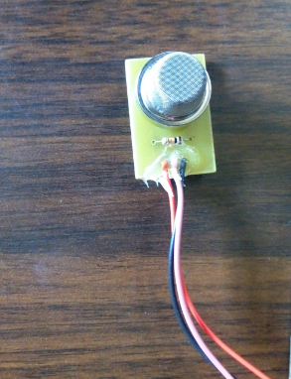

**Fig 5.2.1: Ultrasonic sensor Fig 5.2.2: Gas Sensor**

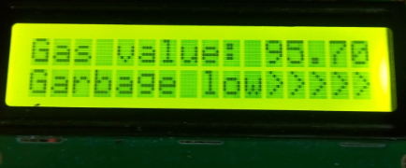

**Fig 5.2.3: Showing status as garbage low**

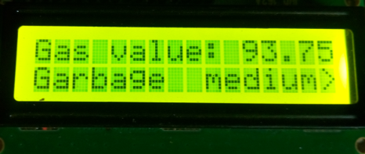

**Fig 5.2.4: Showing status as garbage medium**

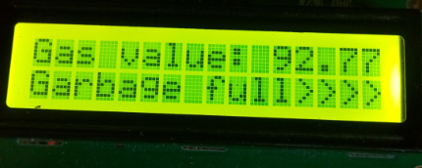

**Fig 5.2.5: Showing status as garbage full**

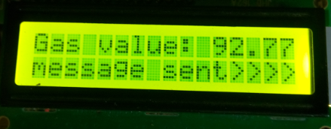

**Fig 5.2.6: Showing status as message sent**

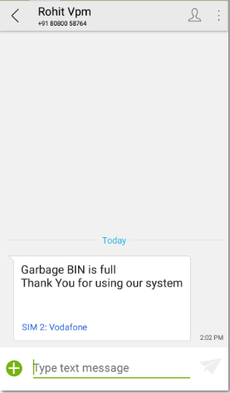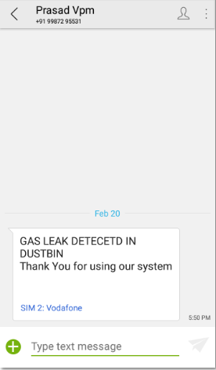

**Fig 5.2.7: Receiving SMS as bin is full Fig 5.2.8: Receiving SMS as Gas leak**

# 5.3 **CODING**

#include<LiquidCrystal.h>

#define RS 2 // D13

#define EN 3 // D8

#define D4 4 // D9

#define D5 5 // D10

#define D6 6 // D11

#define D7 7 // D12

#define ROWS 2 // No. of rows

#define COLS 16 // No. of columns

LiquidCrystal lcd (RS, EN, D4, D5, D6, D7);

//**************Garbage sensor 1 initializaiton************

#define ECHO 12

#define TRIG 13

int GAS = 0;

//***************Global variables for storing values of the sensors******************

int gas_value = 0;

int BUZZER = 9;

int garbage_size = 0;

void lcdClear()

{

lcd.clear();

}

void collegeName(){

lcdPrintLine1("V.P.M.POLY ");

lcdPrintLine2("Year 2017-18 ");

delay(2000);

lcdClear();

lcdPrintLine1("GSM garbage " );

lcdPrintLine2("Monitoring system. ");

delay(2000);

lcdClear() ;

}

int getDistance()

{

long duration;

float distance;

digitalWrite(TRIG, LOW);

delayMicroseconds(2);

// Sets the trigPin on HIGH state for 10 micro seconds

digitalWrite(TRIG, HIGH);

delayMicroseconds(10);

digitalWrite(TRIG, LOW);

// Reads the echoPin, returns the sound wave travel time in microseconds

duration = pulseIn(ECHO, HIGH);

// Calculating the distance

distance= duration;

//Serial.println("Distance value: " + String(distance));

return int(distance);

}

void setup() {

//*********************initialize LCD pinout*************************

pinMode (RS, OUTPUT);

pinMode (EN, OUTPUT);

pinMode (D4, OUTPUT);

pinMode (D5, OUTPUT);

pinMode (D6, OUTPUT);

pinMode (D7, OUTPUT);

lcd.begin(COLS, ROWS);

lcd.clear();

//*******************************************************************

pinMode(ECHO, INPUT);

pinMode(TRIG, OUTPUT);

pinMode(GAS, INPUT);

delay(100);

collegeName();

lcdClear();

delay(2000);

}

void loop(){

//normal_sms();

garbage_size = getDistance();

float gas_value = 5.0 * analogRead(GAS);

if( garbage_size >= 0 && garbage_size<=40)

{

lcdPrintLine1("Gas value: " + (gas_value));

lcdPrintLine2("Garbage level:" + (garbage_size) );

}

if (gas_value > 390 )

{

lcdPrintLine1("GAS DETECTED" );

delay(1000);

digitalWrite(BUZZER, HIGH); // turn the BUZZER on (HIGH is the voltage level)

delay(1000);

action_sms4();

}

if( garbage_size >= 11 && garbage_size<=20)

{

//Serial.println(String(garbage_size) + "*0\n?" );

lcdPrintLine2("Garbage medium>>>>" );

//lcdPrintLine2("" + String(garbage_size) );

delay(1000);

}

if( garbage_size >= 20 && garbage_size<=29)

{

lcdPrintLine2("Garbage low>>>>>" );

delay(1000);

}

if( garbage_size<=10)

{

lcdPrintLine2("Garbage full>>>>>> " );

delay(1000);

digitalWrite(BUZZER, HIGH); // turn the BUZZER on (HIGH is the voltage level)

delay(1000); // wait for a second

action_sms3();

}

delay(500);

lcdClear();

}

void action_sms3()

{

Serial.println("AT+CMGS=\"07058211754\""); // use your 10 digit cell no. here

delay(1000);

Serial.println("Garbage BIN is full ");

Serial.println("Thank You for using our system\n");

delay(1000);

lcdPrintLine2("message sent" );

delay(1000);

digitalWrite(BUZZER, LOW);

}

void action_sms4()

{

Serial.println("AT+CMGS=\"07058211754\""); // use your 10 digit cell no. here

delay(1000);

Serial.println("GAS LEAK DETECETD IN DUSTBIN ");

Serial.println("Thank You for using our system\n");

delay(1000);

delay(1000);

lcdPrintLine2("message sent>>>>" );

delay(1000);

digitalWrite(BUZZER, LOW);

}

# CHAPTER NO. 6

## **TESTING**

**6.1** What is Testing?

In computer hardware and software development, testing is used at key checkpoints in the overall process to determine whether objectives are being met.

It can also stated as the process of validating and verifying that a software program or application or product:

* Meets the business and technical requirements that guided its design and development
* Works as expected
* Can be implemented with the same characteristics

**Various types of testing throughout development cycle of our product**

* **Unit testing:** It is a method by which individual units of source code, sets of one or more modules together with associated control data and operating procedures are tested.
* **Subsystem testing:** It is the highest test level with fewest requirements to be verified. Subsystem interactions, quantity of field devices, external interfaces should remain to be formally verified.
* **System integration testing:** It is a process that exercise a system’s coexistence with others. With multiple integrated systems, assuming that each have already passed system testing.
* **Regression testing:** It is a testing that ensures that previously developed and tested module still perform the same way after it is changed with other module.
* **Beta testing:** It is second phase testing in which a sampling of the intended audience tries the product out.

**6.2**TEST CASES

**Unit Testing**

|  |  |  |  |  |  |  |  |
| --- | --- | --- | --- | --- | --- | --- | --- |
| **Sr**  **No** | **Test ID** | **Test case**  **Objective** | **Steps** | **Input** | **Expected**  **Output** | **Actual**  **Output** | **status** |
| **1** | **TC 01** | **To check the Power supply** | **i)Plug the pin into socket.**  **ii)Switch on the button** | **230V AC** | **+5V DC** | **+5V**  **DC** | **pass** |
| **2** | **TC 02** | **To check working of LCD display** | **i)Place LCD on board.**  **ii)Switch on button to see working** | **Power supply of 5V DC** | **It should display text ‘VPM POLY’** | **It is displaying ‘VPM POLY’** | **pass** |
| **3** | **TC 03** | **To check Buzzer** | **i)Connect buzzer to Arduino.**  **ii)Switch on button, makes condition true it should beeps.** | **Making condition true as ‘Bin is Full’ or ‘Gas leak detected’** | **It should beeps the sound** | **It is beeping the sound** | **pass** |
| **4** | **TC 04** | **To check sending of SMS** | **i)Place sim card into GSM**  **ii)Makes condition true.** | **Throwing of garbage or leakage of gas.** | **It should send SMS as ‘Bin is FULL’ or ‘Gas leak detected’** | **It is sending SMS as ‘Bin is FULL’ or ‘Gas leak detected’** | **pass** |
| **5** | **TC 05** | **To check working of ultrasonic sensor** | **Connect ultrasonic to the Digital pin of Arduino Nano** | **Throwing of garbage or in to dustbin.** | **It should show “bin full” meassage on LCD.** | **It is displaying “Bin is full”on LCD.** | **pass** |

**Integration Testing**

|  |  |  |  |  |  |  |  |
| --- | --- | --- | --- | --- | --- | --- | --- |
| **1** | **TC**  **01** | **To check the garbage level as LOW** | **i)Deploy ultrasonic sensor on bin.**  **ii)Start throwing of garbage till 0% - 25%** | **Throwing of garbage** | **It should display ‘Garbage is LOW’ on LCD** | **It is displaying ‘Garbage is LOW’ on LCD.** | **Pass** |
| **2** | **TC**  **02** | **To check garbage level as MEDIUM** | **i)Deploy ultrasonic sensor on bin.**  **ii)Start throwing of garbage till 25% - 50%** | **Throwing of garbage** | **It should display ‘Garbage is MEDIUM’ on LCD.** | **It is displaying ‘Garbage is MEDIUM’ on LCD.** | **Pass** |
| **3** | **TC**  **03** | **To check garbage level as FULL** | **i)Deploy ultrasonic sensor on bin.**  **ii)Start throwing of garbage till 50% - 75%** | **Throwing of garbage** | **It should display ‘Garbage is FULL’ on LCD.** | **It is displaying ‘Garbage is FULL’ on LCD** | **Pass** |
| **4** | **TC 04** | **To check if gas sensor is detecting combustible gases** | **i)Deploy gas sensor on bin.**  **ii) discharge combustible gas into bin.** | **discharge combustible gas into bin.** | **It should display ‘Gas leak detected’ on LCD** | **It is displaying ‘Gas leak detected’ on LCD** | **Pass** |

**System Testing**

|  |  |  |  |  |  |  |  |
| --- | --- | --- | --- | --- | --- | --- | --- |
| **Sr**  **No** | **Test ID** | **Test case**  **Objective** | **Steps** | **Input** | **Expected**  **Output** | **Actual**  **output** | **Pass** |
| **1** | **TC**  **01** | **To check garbage level as FULL and sending SMS via GSM** | **i)Deploy ultrasonic sensor on bin.**  **ii)Start throwing of garbage till 50% - 75%** | **Throwing of garbage** | **It should display ‘Garbage is FULL’ on LCD and send SMS to the registered user via GSM** | **It is displaying ‘Garbage is FULL’ on LCD and sending sms to the intended user** | **Pass** |
| **2** | **TC**  **02** | **To check if the carbon monoxide is detected and sending SMS via GSM** | **i)Deploy gas sensor on bin.**  **ii)dischargecarbon monoxide into bin.** | **Throwing of substance that contains carbon monoxide** | **It should display ‘Gas leak detected’ on LCD and send SMS to the registered user via GSM** | **It is displaying ‘Gas leak detected’ on LCD and sending SMS to the intended user via GSM** | **Pass** |
| **3** | **TC**  **03** | **To check if carbon is detected and sending SMS via GSM** | **i)Deploy gas sensor on bin.**  **ii) discharge carbon into bin.** | **Throwing of substance that contains carbon** | **It should display ‘Gas leak detected’ on LCD** | **It is displaying ‘Gas leak detected’ on LCD and sending SMS to the intended user via GSM** | **Pass** |
| **4** | **TC 04** | **To check if LPG gas is detected and sending SMS via GSM** | **i)Deploy gas sensor on bin.**  **ii)Throw anything that leaks LPG gas into bin.** | **Throwing of substance that contains LPG gas** | **It should display ‘Gas leak detected’ on LCD** | **It is displaying ‘Gas leak detected’ on LCD and sending SMS to the intended user** | **Pass** |
| **5** | **TC 05** | **To check if**  **methane is detected and send SMS via GSM** | **i)Deploy gas sensor on bin.**  **ii) discharge methane into bin.** | **Throwing of substance that contains methane** | **It should display ‘Gas leak detected’ on LCD** | **It is displaying ‘Gas leak detected’ on LCDand sending SMS to the intended user** | **Pass** |
| **6** | **TC 06** | **To check if methyl alcohol is detected and send SMS via GSM** | **i)Deploy gas sensor on bin.**  **ii) discharge methyl alcohol into bin.** | **Throwing of substance that contains methyl alcohol** | **It should display ‘Gas leak detected’ on LCD** | **It is displaying ‘Gas leak detected’ on LCDand sending SMS to the intended user** | **Pass** |
| **7** | **TC**  **07** | **To check if Diesel is detected and send SMS via GSM** | **i)Deploy gas sensor on bin.**  **ii) discharge diesel into bin.** | **Throwing of substance that contains disel** | **It should display ‘Gas leak detected’ on LCD** | **It is displaying ‘Gas leak detected’ on LCD and sending SMS to the intended user** | **Pass** |
| **8** | **TC 08** | **To check if Natural gas is detected and send SMS via GSM** | **i)Deploy gas sensor on bin.**  **ii) discharge natural gas into bin.** | **Throwing of substance that contains natural gas** | **It should display ‘Gas leak detected’ on LCD** | **It is displaying ‘Gas leak detected’ on LCDand sending SMS to the intended user** | **Pass** |
| **9** | **TC 9** | **To check if nitro benzene is detected and send SMS via GSM** | **i)Deploy gas sensor on bin.**  **ii) discharge nitro benzene into bin.** | **Throwing of substance that contains nitro benzene** | **It should display ‘Gas leak detected’ on LCD** | **It is displaying ‘Gas leak detected’ on LCDand sending SMS to the intended user** | **status** |
| **10** | **TC 10** | **To check if chloroform is detected and send SMS via GSM** | **i)Deploy gas sensor on bin.**  **ii) discharge chloroform into bin.** | **Throwing of substance that contains chloroform** | **It should display ‘Gas leak detected’ on LCD** | **It is displaying ‘Gas leak detected’ on LCDand sending SMS to the intended user** | **Pass** |
| **11** | **TC 11** | **To check if methyl is detected and send SMS via GSM** | **i)Deploy gas sensor on bin.**  **ii) discharge methyl into bin.** | **Throwing of substance that contains methyl** | **It should display ‘Gas leak detected’ on LCD** | **It is displaying ‘Gas leak detected’ on LCDand sending SMS to the intended user** | **Pass** |
| **12** | **TC 12** | **To check if ethanol is detected and send SMS via GSM** | **i)Deploy gas sensor on bin.**  **ii) discharge ethanol into bin.** | **Throwing of substance that contains ethanol** | **It should display ‘Gas leak detected’ on LCD** | **It is displaying ‘Gas leak detected’ on LCDand sending SMS to the intended user** | **Pass** |

**Beta Testing**

|  |  |  |  |  |  |  |  |
| --- | --- | --- | --- | --- | --- | --- | --- |
| **1** | **TC 01** | **To check receiving of SMS when dustbin is full** | **i)Makes condition true**  **ii)Receiving of SMS to mobile users** | **Throwing of garbage**  **Till it is full.** | **It should receive SMS as ‘Bin is FULL’ to the intended mobile user** | **It is receiving SMS as ‘Bin is FULL’ to the intended mobile user** | **pass** |
| **2** | **TC**  **02** | **To check receiving of SMS when gas is leaked** | **i)Makes condition true**  **ii)Receiving of SMS to mobile user** | **Throwing of garbage or leakage of gas.** | **It should receive SMS as ‘Bin is FULL’ or ‘Gas leak detected’ on mobile** | **It is receiving SMS as ‘Bin is FULL’ or ‘Gas leak detected’ on mobile** | **pass** |

# CHAPTER NO.7

**SUMMERY**

7.1 FEATURES:

* The smart, sensor based dustbin will judge the level of waste in it and send the messege to the registered mobile number.
* It can sense all the type of waste material either it is in the form of solid or liquid.
* According to the filled level of the dustbin, the user can decide to clean out the dustbin before it overlows.
* By detecting combustible gases user can avoid any harm caused due to them.
* It emphasizes on “SMART CITY”.
* It emphasizes on “DIGITAL INDIA”.
* The system is simple. If there is any problem with any equipment in the future, that part is easily replaceable with new one without any difficulty and delay.

7.2 ADVANTAGES**:**

* Gas leak is detected before any problem is caused to the surrounding.
* Our smart operating system enable two way communication between the dustbin deployed in the building and service operator. Therefore the focus is only on collecting the waste only when the level indicates high.
* The sensors installed in the containers provide real time information on the fill level.
* In this way both service providers and citizens benefit from an optimized system which results in major cost savings and less urban pollution.
* Applying this technology to the societiesoptimizes management, resources and costs, and makes it a “SMART CITY”.
* It keeps the surroundings clean and green, free from bad odour of wastes, emphasizes on healthy environment and keep cities more beautiful.
* User does not need to continuously monitor the dustbin and worry about overflowing problems

# CHAPTER NO. 8

## **FUTURE SCOPE**

* While dealing with dustbins in societies we can use video processing, which will improve the reliability of circuit.
* Also we can assign garbage ID (GID) to every system hence, it will help to track the position of dust bin.
* We can connect Arduino Nano with wifi hence we can send the status of dustbin on a mobile app.
* We can create new application for garbage monitoring which will show overview of dustbin.

## **CONCLUSION**

By implementing this project we will be able to monitor the level of garbage in the dust bins placed at buildings or hospitals, according to that we can collect garbage when system shows status as ‘Bin is Full’. This system will help avoid overflow conditions and any harm caused due to combustible gases. This project is a more efficient way to monitor waste in the future upcoming smart cities. Hence intelligent smart waste management will makes the garbage collection more efficient.

# CHAPTER NO. 10

**BIBLIOGRAPHY**

[1]http://tocondonews.com/archives/garbage-chute- systems-managing- garbage-large-

buildings/

[2]https://store.arduino.cc/usa/arduino-nano

[3] Prakash, Prabhu,“IoT based management system for smart cities”, International Journal of InnovativeResearch in Science, Engineering and Technology, vol 4, Issue 2, February 2016.

[4] Kanchan Mahajan, Prof J. S. Chitode,”Waste Bin Monitoring system Using Integrated Technologies”,International Journal of Innovative Research in Science, Engineering and Technolgy(An ISO 3297:2007 Certified Organization) Vol 3, Issue 7, July 2014.

[5] Prof.R.M.Sahu, Akshay Godse, Pramod Shinde, Reshma Shinde,” Garbage and Street Light Monitoring System using Internet of Things”, International Journal of Innovative Resarch in Electrical, Electronics,Instrumentation and Control Engineering, Vol 4, Issue 4, 4 April 2016.